# Chapter 2: Analysis

The analysis section of the book reading software is divided into subsections. The subsections are:

1. Introduction
2. Feasibility study
3. Requirement analysis
4. Use case
5. NLA

## 2.1 Introduction

Analysis in a project means the realization of what the project is trying to achieve. In other word division of complex topics into smaller topics in order to gain better understanding and output. This section describes “what is being done” like the things that are out of scope or necessary assumptions in the project. The activities that are involved in analysis is shown below in the diagram.

Analysis is an important phase of development it is done to gain better understating of complex topics, to make strategy, to calculate the output, for requirement gathering etc. So, to determine what are needed in the system, I will be using SWOT analysis.

**SWOT analysis:** Is a technique to understand strengths, weakness, opportunities and threats of a person or organization etc. So, to analysis the book reading system, I have implemented SWOT analysis. So, I can know:

1. The strength of the application.
2. Find the weakness and try to improve it.
3. Change according to the technology when there are any opportunities.
4. To analyse preventive measures to prevent threats etc.

Using SWOT analysis will be benefitable in Book reading system because it will help to support in more decisive and knowledgeable decision making. Since Book reading system is an application it may have its flaws so using SWOT will be beneficial to analyse the outcome maintain it.

## 2.2 Feasibility study

A feasibility study is an analysis that takes all the project relevant factors like economic, technical, legal and scheduling to ascertain the likelihood of the project. In many projects feasibility study is used to determine the pros and cons of the project like what must they spend their time and money on etc.

So, for the Book reading system I have used the feasibility study to determine if the project will be successfully developed or not what are the pros and cons of the system and what can be done to make it better. The feasibility study is divided into five types and they are:

1. **Economic feasibility:**

This feasibility involves the cost/ benefits analysis of the project. Since it derives the total budget of the Book reading system. It checks if the budget is sufficient to develop the project, if not then it will manage it. so that there won’t be any economical problem while developing the system.

1. **Technical feasibility:**

This feasibility focuses on the technical resources available on the project which will help to meet the capacity whether the technical term is capable of converting the ideas into working system. So, the technical resources that are available are sufficient to develop the Book reading system.

1. **Schedule feasibility:**

This feasibility is the most important type of feasibility which keeps the track of time. After all the project will fail if it is not completed on time. In scheduling feasibility time is estimated for project will take to complete. Likewise, in the book reading system I have estimated 3 months of total time to develop it.

1. **Operational feasibility:**

This feasibility measures how well the company can identify and solve the problem. As I have implemented SWOT analysis for the Book reading system the analysis will identify all the strength, weakness, threats etc which will help the operational feasibility.

1. **Legal feasibility:**

This feasibility identifies does the product met all the permitted and ethical requirement? The Book reading system that I am going to create meets all the legal and law of my country. So that it may not cause any trouble while developing the project.

## 2.3 Requirement analysis

requirement analysis is the process of defining the expectation of the users for an application that is to be build or modified. Therefore, requirement analysis means to analysis, document, validate and manage the software requirement.

In the requirement analysis I will be using some of the method to identify all the requirement that are needed for the book reading system. The methods to identify the requirement are shown below:

1. **Functional requirement:**

The functional requirement defines the functions that are carried out in the system. It describes the system’s behaviour.

|  |  |  |  |  |  |
| --- | --- | --- | --- | --- | --- |
| PF.ID | Function | Data | Rational | Dependency | Description |
| PF1 | Login | User input (Username and password) | For security purposes | No dependency | User can login to their personal account. |
| PF2 | Personal account | No data | Personal library | PF1 | User all data are stored here. |
| PF3 | Add books | Text document | Publishing new books | PF2 | To add books. |
| PF4 | Font adjustment | Text document | To make system user friendly | PF3 | To increase book reading experience of user. |
| PF5 | Voice reader | Text document | To make system user friendly | PF3 | To save time of readers. |

1. **Non-functional requirement:**

The non-functional requirement specifies criteria that judge the operation of the system, rather than specific behaviours. Some typical non-functional requirements are scalability, availability, maintainability etc.

|  |  |  |  |  |
| --- | --- | --- | --- | --- |
| PF.ID | Function | Rational | Dependency | Description |
| NF1 | Usability | To develop a system which can be used by all people. | PF1, PF2 | The system must be usable and easy to user for the user. |
| NF2 | Performance | To provide result faster. |  | The system should be able to analyse the sentiments within a short time depending upon the overall volume of words to be analysed. |
| NF 3 | Reliability | To provide a reliable system that has less failure |  | The system should never fail at its functionality and should have less MTBF (mean time between failures) |
| NF4 | Scalability | To handle the load of data |  | The system should handle the load of incoming all data. |

1. **MoSCoW prioritization:**

The method is a prioritization technique used in project management, software development to reach a common understanding between the stakeholder on the importance they play in the requirement.

The term MoSCoW is an acronym which all capital letters have their meaning the full form is (Must have, should have, could have, Won’t have).

* Must have: requirement must have labelled as must have are the critical and is success to be implemented.
* Should have: requirement labelled as should have are important but not necessary to be implemented.
* Could have: requirement labelled as could have are desirable but not necessary.
* Won’t have: requirement labelled as won’t have been agreed by stakeholder as not appropriate requirement for the time.

|  |  |
| --- | --- |
| Requirements | MoSCoW |
| Login | Should have |
| Personal account | Must have |
| Add book | Must have |
| Font adjustment | Should have |
| Voice reader | Should have |
| Usability | Must have |
| Performance | Should have |
| Reliability | Should have |
| Scalability | Must have |

## 2.4 Use case diagram

Use case is one of the dynamic behavioural diagrams of UML. It shows what the Function are in the system and who operates. Use case consist of actors, use cases, relationship between them etc. A single use case diagram captures the functionality of a system. The Purpose of using use case is to capture the dynamic aspect of a system. The use case diagram of Book reading system is shown below:

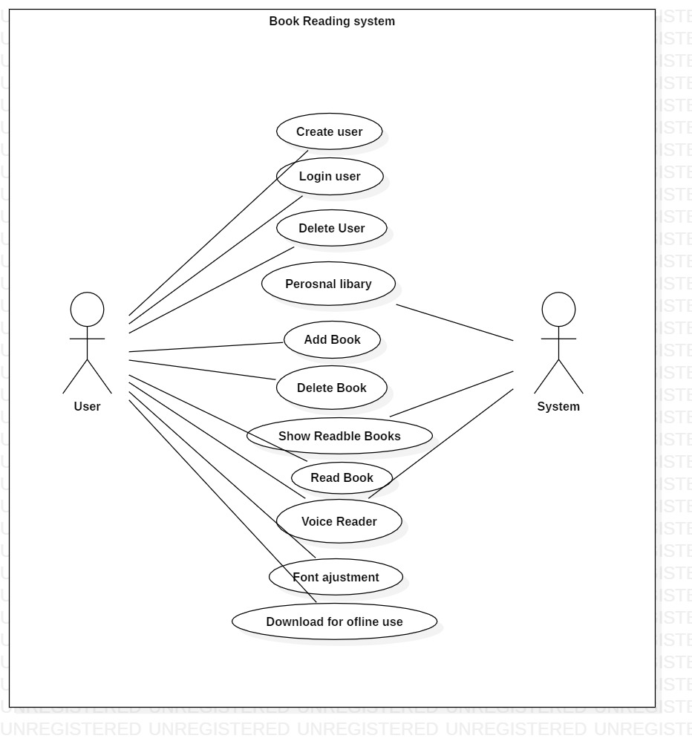

Fig: Use case diagram of book reading system.

## 2.5 NLA (Natural language analysis)

**Scenario**

The time is changing as we speak and as well as the technology. The people are getting modern day by day. The people can share every single detail to a certain person who is in the other side of the world. The development of technology is also affecting the modern education process, In the modern education process people don’t only read form text book or go to library for research they can read/research from the mobile, iPad and different other devices through internet. Similarly, you been assigned to develop a project named “**Book reading system”** which help the user to read book at any places as they please.

It is an electronic version of tradition printed book that can be read by using smart phones. The project is a type of eBook application software like Kindle, calibre etc. The programming language to develop the application will be Java because it is the most popular language for developing mobile application.

While adding new book the details must be given like: Title, author, year, publisher, document type, volume etc.

Your task for the assignment is to implement the following function on the application

* Permits users to be added, and removed from the system.
* Books to be added, removed from the system.
* Font adjustment features should be implemented while reading books.
* Voice reader activation must be provided.
* Personal library after user have logged in.
* Books can be downloaded for offline use.

**NLA of the scenario**

The NLA (Natural Language analysis) is a process to analyse the scenario and provide proper Classes, method and Attributes by selecting all the nouns, verbs and adjective form the scenario. For example, we are provided with a scenario where we analyse the requirement and filter the candidate classes and candidate method.

Selecting all the nouns and verbs from the scenario

|  |  |
| --- | --- |
| Nouns | Verbs |
| Time, technology, people, modern, days, person, world, technology, education, book, library, book, user, book, electronic, traditional, read, eBook, application, software, | User added, user deleted, user update, book added, book removed, font adjustment, voice reader, personal library, download books. |

Identifying candidate class for book reading system.

|  |  |
| --- | --- |
| SN | Candidate class |
| 1. | User |
| 2. | Book |
| 3. | Library |

Identifying Candidate verbs from the scenario.

|  |  |
| --- | --- |
| SN | Verbs |
| 1 | Add user |
| 2. | Remove user |
| 3. | Update user |
| 4. | Add books |
| 5. | Remove books |
| 6. | Font adjustment |
| 7. | Voice reader |
| 8. | Personal library |
| 9. | Download books |

Class diagram of Book reading system.

